* Copyright for test papers and marking guides remains with *West Australian Test Papers*.
* The papers may only be reproduced within the purchasing school according to the advertised conditions of sale.
* Test papers must be withdrawn after use and stored securely in the school until Friday 4th December 2015.

**HUMAN BIOLOGICAL**

**SCIENCE**

**UNITS 1 & 2**

**2015**



Name: _______________________________________________________

Teacher: ___________________________________________________

# *TIME ALLOWED FOR THIS PAPER*

## Reading time before commencing work: Ten minutes

Working time for the paper: Three hours

# *MATERIALS REQUIRED/RECOMMENDED FOR THIS PAPER*

**To be provided by the supervisor:**

* This Question/Answer Booklet
* Multiple Choice Answer Sheet

**To be provided by the candidate:**

* Standard items: Pens, pencils, eraser or correction fluid, ruler, highlighter, ruler.
* Special items: Calculators satisfying the conditions set by the Curriculum Council for this subject.

# *IMPORTANT NOTE TO CANDIDATES*

* No other items may be taken into the examination room. It is **your** responsibility to ensure that you do not have any unauthorised notes or other items of a non-personal nature in the examination room. If you have any unauthorised material with you, hand it to the supervisor **before** reading any further.

***Structure of this paper***

|  |  |  |  |  |
| --- | --- | --- | --- | --- |
| Section | Suggested working time | Number of questions available | Number of questions to be attempted | Marks |
| SECTION ONE:  Multiple-choice | 40 minutes | 30 | All | 60 |
| SECTION TWO:  Short answers | 90 minutes | 8 | All | 100 |
| SECTION THREE:  Extended answers | 50 minutes | 3 | 2 | 40 |
|  |  |  | Total marks | 200 |

**Instructions to candidates**

1. The rules for the conduct of Western Australian external examinations are detailed in the *Year 12 Information Handbook 2015.* Sitting this examination implies that you agree to abide by these rules.

2. Answer the questions according to the following instructions.

Section One: Answer all questions on the separate Multiple-choice Answer Sheet provided. For each question shade the box to indicate your answer. Use only a blue or black pen to shade the boxes. If you make a mistake, place a cross through that square, do not erase or use correction fluid, and shade your new answer. Marks will not be deducted for incorrect answers. No marks will be given if more than one answer is completed for any question.

Sections Two and Three: Write your answers in this Question/Answer Booklet.

3. You must be careful to confine your responses to the specific questions asked and to follow any instructions that are specific to a particular question.

4. Spare pages are included at the end of this booklet. They can be used for planning your responses and/or as additional space if required to continue an answer.

* + Planning: If you use the spare pages for planning, indicate this clearly at the top of the page.
  + Continuing an answer: If you need to use the space to continue an answer, indicate in the original answer space where the answer is continued, i.e. give the page number. Fill in the number of the question(s) that you are continuing to answer at the top of the page.

**Section One: Multiple-choice 30% (60 Marks)**

This section has **30** questions. Answer **all** questions on the separate Multiple-choice Answer Sheet provided. For each question shade the box to indicate your answer. Use only a **blue or black pen** to shade the boxes. If you make a mistake, place a cross through that square, do not erase or use correction fluid, and shade your new answer. Marks will not be deducted for incorrect answers. No marks will be given if more than one answer is completed for any question.

Suggested working time for this section is 40 minutes.

1. Determine which of the following statements about ATP is **incorrect.**

a) Surplus energy from respiration is transferred to ATP as a long term energy store.

b) ATP contains a readily available supply of energy for our muscles.

c) Energy from ATP causes muscle tissue to contract.

d) ATP is formed from ADP and Phosphate.

A respiratory system may have the following features:

1. A large surface area available for diffusion
2. A thin surface through which diffusion occurs
3. A large distance over which diffusion occurs
4. A small concentration gradient inside and outside the system
5. A moist surface through which diffusion occurs.
6. Which of the five alternatives (i-v) would be present in an efficient respiratory system:

a) i, ii, iii, v

b) i, ii, v

c) i, ii, iv, v

d) i, ii, iii, iv, v

1. Transmission of a sexually transmitted virus, such as herpes, can be prevented by:
2. treatment with antivirals
3. using condoms
4. avoiding vaginal intercourse
5. treatment with antibiotics
6. A homozygous recessive genotype means:

a) an individual has 2 recessive alleles

b) an individual only expresses their dominant allele

c) an individual has both a recessive and a dominant allele

d) an individual has 2 dominant alleles

The diagram below illustrates part of a cell membrane.

*(source:* [*http://www.quia.com/jg/2139604list.html*](http://www.quia.com/jg/2139604list.html)*)*

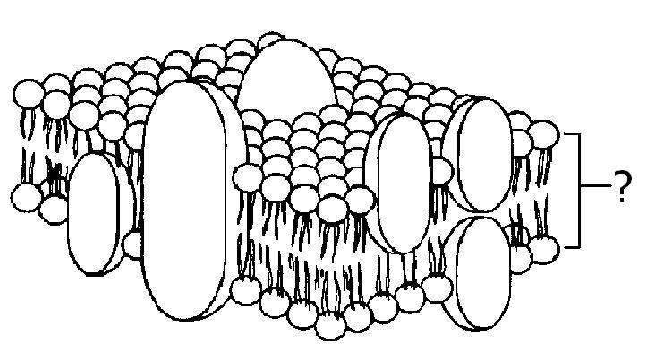

Y

1. The region labelled Y is:

a) non-polar

b) hydrophilic

c) hydrophobic

d) hydrostatic

Question 6 refers to the following pedigree which shows the inheritance of an X-linked dominant trait in a family.

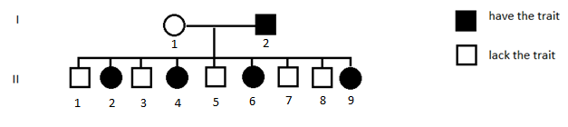

1. It is reasonable to assume that the:

a) mother of I 1 had the trait.

b) father of I 1 had the trait.

c) mother of I 2 had the trait.

d) father of I 2 had the trait.

1. During stage 2 of labour:

a) the placenta is delivered

b) the cervix begins to widen

c) contractions begin

d) the cervix reaches its maximum dilation

A long distance runner took part in some laboratory tests using a treadmill.

She was asked to use the treadmill at a setting of 4 km/h for three minutes during which her pulse rate was monitored. At the end of this time a blood sample was taken which was tested for lactic acid concentration. The procedure was repeated with the runner moving at 8 km/h and 12 km/h for a period of 3 minutes each.

1. The independent variable for this experiment is the:
2. lactic acid concentration in the blood
3. distance run
4. treadmill speed
5. pulse rate
6. Which of the following is a controlled variable in this experiment?
7. Time on the treadmill
8. Lactic acid concentration in the blood
9. Distance run
10. Treadmill speed
11. Which of the following occurs during inspiration?
12. Intercostal muscles relax and the ribs move up and out
13. Diaphragm relaxes and moves downwards
14. Pressure inside the chest cavity increases
15. Volume inside the chest cavity increases
16. Where would unbound DNA be found?

a) Cytoplasm

b) Mitochondria

c) Nucleus

d) Nucleolus

Question 12 refers to the diagram below which shows a generalised cell.  
*(Source:* [*www.exploringnature.org*](http://www.exploringnature.org)*)*

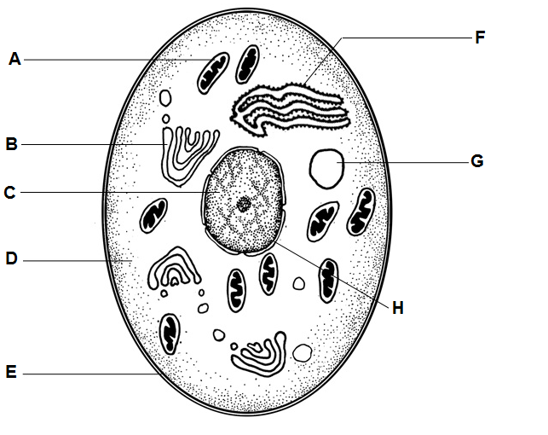

1. The function of structure F is to:
2. build protein
3. support cell shape
4. control cell activities
5. release energy from food
6. Contraception can either be classed as hormonal, chemical or physical barriers. Which of the following correctly lists one of each method respectively?

|  |  |  |  |
| --- | --- | --- | --- |
|  | **Hormonal** | **Chemical** | **Physical** |
| a) | Pill | Mini pill | Diaphragm |
| b) | Pill | Spermicide | Condom |
| c) | Implanon | IUD | Diaphragm |
| d) | Mini pill | Implanon | Condom |

Question 14 refers to the diagrams below which show two stages of mitosis in cells.

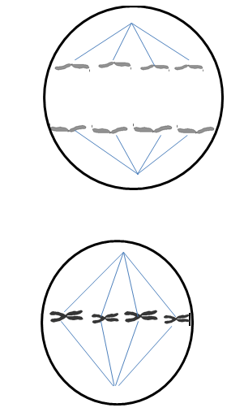

Diagram 2

Diagram 1

1. Diagram 1 and 2 can be represented by which of the two sentences provided?

|  |  |  |
| --- | --- | --- |
|  | **Diagram 1** | **Diagram 2** |
| a) | Chromatids are pulled to opposite ends of the cell | Chromosomes line up at the centre of the cell |
| b) | Nuclear membrane reforms | Chromosomes line up at the centre of the cell |
| c) | Chromatids are pulled to opposite ends of the cell | Chromosomes shorten and thicken |
| d) | Chromosomes shorten and thicken | Chromosomes line up at the centre of the cell |

1. Which of the following is the correct order of structures through which sperm pass during ejaculation?
2. Urethra, vas deferens, epididymis
3. Epididymis, vas deferens, urethra
4. Vas deferens, urethra, epididymis
5. Vas deferens, seminiferous tubules, urethra

Question 16 refers to the diagram below which shows the process of implantation.

*(Source:* [*http://thebrain.mcgill.ca/flash/a/a_09/a_09_cr/a_09_cr_dev/a_09_cr_dev.html*](http://thebrain.mcgill.ca/flash/a/a_09/a_09_cr/a_09_cr_dev/a_09_cr_dev.html)*)*

[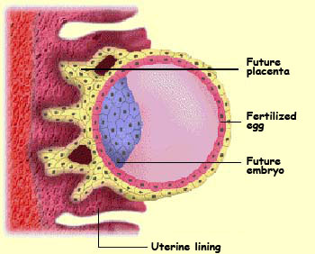](http://www.google.com.au/url?sa=i&rct=j&q=&esrc=s&frm=1&source=images&cd=&cad=rja&uact=8&ved=0CAcQjRw&url=http://thebrain.mcgill.ca/flash/a/a_09/a_09_cr/a_09_cr_dev/a_09_cr_dev.html&ei=GcQXVbHUEomK8QWQooGAAg&bvm=bv.89381419,d.dGc&psig=AFQjCNEB6qmDwOOmOHF4PU6AJlhyoPNxGw&ust=1427707134291812)

1. When the above structure implants into the endometrium, it is known as a:

a) zygote

b) blastocyst

c) amnion

d) morula

1. Within two weeks of conception, the inner cell mass or embryo has developed three layers. The outer layer or ectoderm will form the:

a) nervous system, epidermis, hair and nails.

b) muscle, bone, cartilage and blood vessels.

c) glands and linings.

d) ectodermis and ectoplasm layers.

1. Where would spongy and compact bone be located respectively?

|  |  |  |
| --- | --- | --- |
|  | **Spongy bone** | **Compact bone** |
| a) | Epiphysis | Periosteum |
| b) | Diaphysis | Epiphysis |
| c) | Periosteum | Diaphysis |
| d) | Epiphysis | Diaphysis |

1. In the following diagram the movement of the left lower limb which has occurred in moving from position **A** to position **B** include:

**A** **B**

a) flexion at the hip and flexion at the knee

b) flexion at the hip and extension at the knee

c) extension at the hip and flexion at the knee

d) extension at the hip and extension at the knee

Question 20 refers to the diagram of a muscle contractile unit shown below.  
(*Source:* [*http://mcat-review.org/specialized-eukaryotic-cells-tissues.php*](http://mcat-review.org/specialized-eukaryotic-cells-tissues.php)*)*



1. In this contractile unit a sarcomere is:

a) The area between two H lines

b) The area between two A lines

c) The area between two I bands

d) The area between two Z lines

1. Fibrocartilage is found in the:

a) nose

b) trachea

c) ends of long bones

d) intervertebral discs

1. Food travels through which of the following parts of the alimentary canal (in order):

a) mouth, stomach, oesophagus, small intestine, large intestine and rectum

b) mouth, oesophagus, stomach, small intestine, large intestine and rectum

c) mouth, oesophagus, stomach, small intestine, pancreas, large intestine and rectum

d) mouth, oesophagus, stomach, small intestine, liver, pancreas, large intestine and rectum

1. The location in the kidneys of Bowman’s capsule and Loop of Henle are:

a) pelvis and medulla respectively

b) medulla and cortex respectively

c) cortex and medulla respectively

d) Both are located in the medulla

1. Filtration of blood in the glomerulus of the kidneys is primarily dependent on:

a) concentration gradient

b) availability of ATP

c) blood pressure

d) diffusion rate

1. The ability to roll the tongue is an autosomal dominant trait. A woman who cannot roll her tongue and a man who is heterozygous for tongue rolling have a child together. What is the chance that they will have a child who cannot roll their tongue?

a) 25%

b) 50%

c) 75%

d) 0

1. Which type of stem cell has the most potential to differentiate into the greatest diversity of cell types:

a) pluripotent

b) omnipotent

c) multipotent

d) totipotent

Use the following information to answer Question 27.

The table below summarises measurements made of the concentration of the substances in the kidney filtrate of a person.

|  |  |  |
| --- | --- | --- |
| **Substance** | **Concentration (arbitrary units)** | |
|  | Filtrate | Urine |
| Protein Urea  Glucose Sodium | 0 300 1000 3000 | 0 20000 0 3000 |

1. The conclusions that water is reabsorbed in the tubules of the nephron is supported by the data on the relative concentration of:

a) protein

b) urea

c) glucose

d) sodium

1. When is the developing embryo/foetus most susceptible to genetic birth defects from exposure to maternal alcohol levels?

a) First trimester

b) Second trimester

c) Third trimester

d) At birth

1. The atypical growth and spread of abnormal cells is known as:

a) cancer

b) carcinogen

c) biopsy

d) malignant

Use the following information to answer Question 30.

Jane and David gave birth to a baby boy in hospital. On the same day another baby boy was born and unfortunately both babies were given an identification bracelet with the same number on it. This made it difficult for the parents to tell which baby was in fact theirs. A blood sample from both babies and Jane and David was sent to the laboratory for DNA fingerprinting. The DNA fingerprint is shown below:

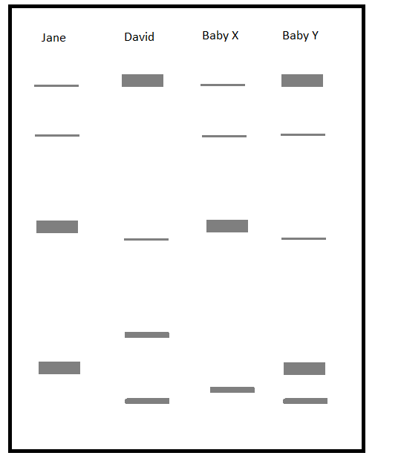

1. The biological son of Jane and David is likely to be:

a) Baby X

b) Baby Y

c) either Baby X or Y

d) neither Baby X or Y

**Section Two: Short answer 50% (100 Marks)**

This section has **eight (8)** questions. Answer **all** questions. Write your answers in the spaces provided.

Spare pages are included at the end of this booklet. They can be used for planning your responses and/or as additional space if required to continue an answer.

Planning: If you use the spare pages for planning, indicate this clearly at the top of the page.

Continuing an answer: If you need to use the space to continue an answer, indicate in the original answer space where the answer is continued, i.e. give the page number. Fill in the number of the question(s) that you are continuing to answer at the top of the page.

Suggested working time for this section is 90 minutes.

**Question 31 (13 marks)**

A group of 1594 women who had been through menopause (postmenopausal) and with diagnosed osteoporosis were recruited into a research study looking at the effect of treatment with *Risedronate* over a three year time period. Women were separated into two groups, one group received a placebo (inactive) treatment and the other group received a daily dose of *Risedronate*. Both the placebo and *Risedronate* were in identical forms so the women were not aware of which medication they were taking. The women kept a diary and recorded any fractures over the 3 year time period.

The results are shown in Table 1:

Table 1: Cumulative fracture rates in postmenopausal women with osteoporosis when given placebo and *Risedronate* over a period of 3 years

|  |  |  |
| --- | --- | --- |
|  | Cumulative fracture rate (%) | |
| Time since taking drug (months) | Placebo group | *Risedronate* group |
| 6  12  16  22  30  36 | 2  5  7  11  13  16 | 2  3  4  6  9  10 |

a) Construct a graph of the data in Table 1 using the grid provided on the next page.

(5 marks)

|  |  |  |  |  |  |  |  |  |  |  |  |  |  |  |  |  |  |  |
| --- | --- | --- | --- | --- | --- | --- | --- | --- | --- | --- | --- | --- | --- | --- | --- | --- | --- | --- |
|  |  |  |  |  |  |  |  |  |  |  |  |  |  |  |  |  |  |  |
|  |  |  |  |  |  |  |  |  |  |  |  |  |  |  |  |  |  |  |
|  |  |  |  |  |  |  |  |  |  |  |  |  |  |  |  |  |  |  |
|  |  |  |  |  |  |  |  |  |  |  |  |  |  |  |  |  |  |  |
|  |  |  |  |  |  |  |  |  |  |  |  |  |  |  |  |  |  |  |
|  |  |  |  |  |  |  |  |  |  |  |  |  |  |  |  |  |  |  |
|  |  |  |  |  |  |  |  |  |  |  |  |  |  |  |  |  |  |  |
|  |  |  |  |  |  |  |  |  |  |  |  |  |  |  |  |  |  |  |
|  |  |  |  |  |  |  |  |  |  |  |  |  |  |  |  |  |  |  |
|  |  |  |  |  |  |  |  |  |  |  |  |  |  |  |  |  |  |  |
|  |  |  |  |  |  |  |  |  |  |  |  |  |  |  |  |  |  |  |
|  |  |  |  |  |  |  |  |  |  |  |  |  |  |  |  |  |  |  |
|  |  |  |  |  |  |  |  |  |  |  |  |  |  |  |  |  |  |  |
|  |  |  |  |  |  |  |  |  |  |  |  |  |  |  |  |  |  |  |
|  |  |  |  |  |  |  |  |  |  |  |  |  |  |  |  |  |  |  |
|  |  |  |  |  |  |  |  |  |  |  |  |  |  |  |  |  |  |  |
|  |  |  |  |  |  |  |  |  |  |  |  |  |  |  |  |  |  |  |
|  |  |  |  |  |  |  |  |  |  |  |  |  |  |  |  |  |  |  |
|  |  |  |  |  |  |  |  |  |  |  |  |  |  |  |  |  |  |  |
|  |  |  |  |  |  |  |  |  |  |  |  |  |  |  |  |  |  |  |
|  |  |  |  |  |  |  |  |  |  |  |  |  |  |  |  |  |  |  |
|  |  |  |  |  |  |  |  |  |  |  |  |  |  |  |  |  |  |  |
|  |  |  |  |  |  |  |  |  |  |  |  |  |  |  |  |  |  |  |
|  |  |  |  |  |  |  |  |  |  |  |  |  |  |  |  |  |  |  |
|  |  |  |  |  |  |  |  |  |  |  |  |  |  |  |  |  |  |  |
|  |  |  |  |  |  |  |  |  |  |  |  |  |  |  |  |  |  |  |
|  |  |  |  |  |  |  |  |  |  |  |  |  |  |  |  |  |  |  |
|  |  |  |  |  |  |  |  |  |  |  |  |  |  |  |  |  |  |  |
|  |  |  |  |  |  |  |  |  |  |  |  |  |  |  |  |  |  |  |
|  |  |  |  |  |  |  |  |  |  |  |  |  |  |  |  |  |  |  |
|  |  |  |  |  |  |  |  |  |  |  |  |  |  |  |  |  |  |  |
|  |  |  |  |  |  |  |  |  |  |  |  |  |  |  |  |  |  |  |
|  |  |  |  |  |  |  |  |  |  |  |  |  |  |  |  |  |  |  |
|  |  |  |  |  |  |  |  |  |  |  |  |  |  |  |  |  |  |  |
|  |  |  |  |  |  |  |  |  |  |  |  |  |  |  |  |  |  |  |
|  |  |  |  |  |  |  |  |  |  |  |  |  |  |  |  |  |  |  |

If you make an error, clearly cross out your attempt and use the spare grid on page 40.

b) Propose a hypothesis for the study.

________________________________________________________________________

________________________________________________________________________

________________________________________________________________________

(2 marks)

c) Describe why the investigators used a placebo in this study.

________________________________________________________________________

________________________________________________________________________

(1 mark)

d) Describe two ways in which the validity of this research study could be improved.

________________________________________________________________________

________________________________________________________________________

(2 marks)

e) Use the graph to predict what the cumulative fracture rate of a patient in the placebo group at 25 months after the start of the study.

________________________________________________________________________

(1 mark)

f) Use the data to summarise the findings of this research study.

________________________________________________________________________

________________________________________________________________________

________________________________________________________________________

________________________________________________________________________

________________________________________________________________________

________________________________________________________________________

________________________________________________________________________

________________________________________________________________________

(2 marks)

**Question 32 (13 marks)**

1. What is epigenetics?

________________________________________________________________________

________________________________________________________________________

(1 mark)

1. List two environmental factors that may cause epigenetic changes in the DNA.

________________________________________________________________________

________________________________________________________________________

(2 marks)

These diagrams show the DNA of men and women who are usually sedentary (inactive). Their DNA was then examined after they experienced a period of intense exercise. The diagram below shows images of the changes in the methylation of DNA after intense exercise for 6 months.

*(Source:* [*http://www.frontiersin.org/files/Articles/68784/fgene-04-00219-r2/image_m/fgene-04-00219-g001.jpg*](http://www.frontiersin.org/files/Articles/68784/fgene-04-00219-r2/image_m/fgene-04-00219-g001.jpg)*)*

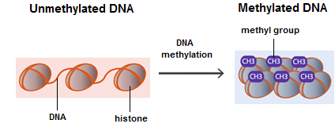

c) DNA methylation was decreased in skeletal muscle biopsies obtained from sedentary men and women after intense exercise.

1. Describe the changes in the DNA

________________________________________________________________________

________________________________________________________________________

________________________________________________________________________

(2 marks)

1. Explain how these changes affect gene expression.

________________________________________________________________________

________________________________________________________________________

________________________________________________________________________

(2 marks)

d) Name and describe two processes that occur during meiosis that contribute to the

variation in offspring.

________________________________________________________________________

________________________________________________________________________

________________________________________________________________________

________________________________________________________________________

________________________________________________________________________

________________________________________________________________________

________________________________________________________________________

________________________________________________________________________

(4 marks)

Use the following diagrams showing stages of meiosis (not in the correct order) to answer part e.

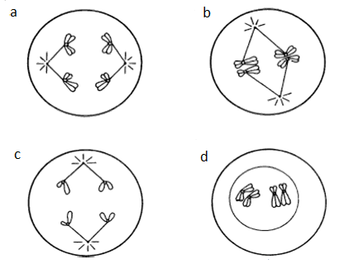

(Source: <http://mrsebiology75.weebly.com/journals/archives/02-2015>)

e) State which diagram represents Anaphase I. Explain what is happening in the cell.

________________________________________________________________________

________________________________________________________________________

________________________________________________________________________

________________________________________________________________________

________________________________________________________________________

(2 marks)

**Question 33 (11 marks)**

The diagram below represents the female reproductive system and the events leading up to the formation of an embryo.

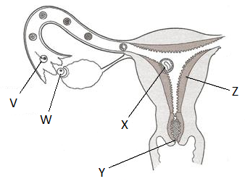*(Source:* [*http://www.naturalfamilyplanning.ie/wp-content/uploads/2008/05/transport.jpg*](http://www.naturalfamilyplanning.ie/wp-content/uploads/2008/05/transport.jpg)*)*   
a) Name the following structures:

Y ______________________________________________

Z ______________________________________________

(2 marks)

b) Name the process occurring at **W** and describe the hormonal trigger for this process.

________________________________________________________________________

________________________________________________________________________

(2 marks)

c) The placenta plays a very important role in the development of **X**. Describe three

functions of the placenta.

________________________________________________________________________

________________________________________________________________________

________________________________________________________________________

________________________________________________________________________

________________________________________________________________________

________________________________________________________________________

(3 marks)

d) Name and describe the roles of two structures found in the foetal circulation which

are not normally present in the baby after birth.

________________________________________________________________________

________________________________________________________________________

________________________________________________________________________

________________________________________________________________________

________________________________________________________________________

________________________________________________________________________

________________________________________________________________________

(4 marks)

**Question 34 (7 marks)**

1. The diagram below shows a DNA molecule.  
   *(Source:* [*http://bioserv.fiu.edu/~walterm/human_online/organic/img030.gif*](http://bioserv.fiu.edu/~walterm/human_online/organic/img030.gif)*)*

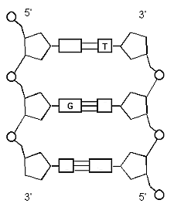

1. Use arrows to label the deoxyribose sugar and the phosphate on the diagram.
2. Name the complimentary base that binds to Thymine ___________________
3. Name the complimentary base that binds to Guanine ___________________

(2 marks)

b) Describe the role of mRNA in protein synthesis.

________________________________________________________________________

________________________________________________________________________

________________________________________________________________________

________________________________________________________________________

(2 marks)

c) Describe the process of translation.

________________________________________________________________________

________________________________________________________________________

________________________________________________________________________

________________________________________________________________________

________________________________________________________________________

________________________________________________________________________

________________________________________________________________________

________________________________________________________________________

________________________________________________________________________

(3 marks)

**Question 35 (10 marks)**

Substances are moved into cells by a variety of transport processes.

a) List two features of active transport.

________________________________________________________________________

________________________________________________________________________

________________________________________________________________________

(2 marks)

b) Name the reactants for aerobic respiration and explain how they enter a cell.

________________________________________________________________________

________________________________________________________________________

________________________________________________________________________

________________________________________________________________________

________________________________________________________________________

(3 marks)

Three eggs were left in dilute hydrochloric acid overnight which dissolved the hard outer shell leaving behind the inner membrane only. These three de-shelled eggs were then left overnight in beakers containing 150cm3 of sugar solutions of different concentrations.

Table 2 shows the results before and after the experiment. Use the information in the table to answer the following questions.

Table 2 – Changes in mass over deshelled eggs overnight in three different sugar solutions

|  |  |  |  |
| --- | --- | --- | --- |
| Egg | Start mass (g) | End mass (g) | Difference (g) |
| 1 | 59.9 | 53.2 |  |
| 2 | 58.4 | 63.6 |  |
| 3 | 57.4 | 57.5 |  |

1. Calculate the difference in mass for each of the eggs. Record your answers in the table.

(1 mark)

1. One of the eggs was placed in concentrated sugar syrup. From the data provided, identify which egg this was.

Egg:

Explain why this change occurred

________________________________________________________________________

________________________________________________________________________

________________________________________________________________________

________________________________________________________________________

________________________________________________________________________

________________________________________________________________________

________________________________________________________________________

________________________________________________________________________

(4 marks)

**Question 36 (15 marks)**

a) Use the list of terms below to match the descriptions of parts of bone.

A. Lacunae E. Osteocytes

B. Canaliculi F. Haversian canal

C. Osteoblasts G. Osteoclasts

D. Lamellae H. Trabeculae

______ Located in the centre of the osteon; contains blood vessels

______ Contain slender extensions that connect one osteocytes to other osteocytes; carry nutrients and waste materials from one osteocyte to another

______ Little spaces that house the bone cells

______ Cylinders of calcified bone found in compact bone

(4 marks)

b) Describe two symptoms and one treatment for osteoarthritis.

________________________________________________________________________

________________________________________________________________________

________________________________________________________________________

________________________________________________________________________

________________________________________________________________________

1. marks)
2. Use the diagram below, showing the bones of the upper arm, to answer the following questions.  
   *(Source:* [*http://www.stadion.com/injuries-biomechanical-factors-that-contribute-to-rotator-cuff-dysfunction-and-injury/*](http://www.stadion.com/injuries-biomechanical-factors-that-contribute-to-rotator-cuff-dysfunction-and-injury/)*)*

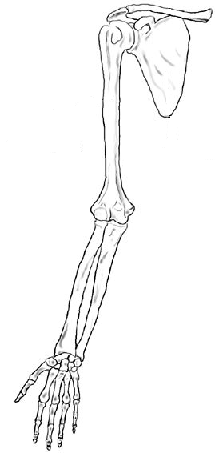

A

B

1. Name the type of joint labelled A and describe the range of movement it allows.

_________________________________________________________________

__________________________________________________________________

(2 marks)

1. Name the type of joint labelled B and describe the range of movement it allows.  
     
   __________________________________________________________________

__________________________________________________________________

(2 marks)

1. Describe one characteristic of a synovial joint.

______________________________________________________________________

______________________________________________________________________

______________________________________________________________________

(1 mark)

1. Explain how the biceps and triceps work together to bring about movement of the lower arm.

______________________________________________________________________

______________________________________________________________________

______________________________________________________________________

______________________________________________________________________

______________________________________________________________________

______________________________________________________________________

(3 marks)

**Question 37 (11 marks)**

Enzymes play an important role in digestion.

a) List two features of enzymes.

________________________________________________________________________

________________________________________________________________________

________________________________________________________________________

(2 marks)

1. Complete the following questions relating to the effect of temperature on enzyme function.
2. Use the axes below to sketch a graph demonstrating how the activity of an enzyme in the human body changes as temperature changes.

Enzyme   
activity   
(units)

Temperature (°C)

1. marks)

ii) Explain the shape of this graph.

________________________________________________________________________

________________________________________________________________________

________________________________________________________________________

________________________________________________________________________

________________________________________________________________________

(3 marks)

c) Describe the role of bile in the mechanical digestion of lipids.

________________________________________________________________________

________________________________________________________________________

________________________________________________________________________

________________________________________________________________________

(2 marks)

d) Name and describe the process by which material is moved through the alimentary canal.

________________________________________________________________________

________________________________________________________________________

________________________________________________________________________

(2 marks)

**Question 38 (20 marks)**

Blood is transported around the body in a number of different blood vessels.

a) Describe one structural difference between veins and arteries.

________________________________________________________________________

________________________________________________________________________

________________________________________________________________________

(1 mark)

b) Describe two ways in which carbon dioxide is transported in the blood.

________________________________________________________________________

________________________________________________________________________

________________________________________________________________________

________________________________________________________________________

(2 marks)

c) Name a symptom resulting from a blockage in a lymph capillary and give a reason for this symptom.

________________________________________________________________________

________________________________________________________________________

________________________________________________________________________

________________________________________________________________________

(2 marks)

1. Describe the sequence of events which occur during ventricular systole.

________________________________________________________________________

________________________________________________________________________

________________________________________________________________________

________________________________________________________________________

________________________________________________________________________

________________________________________________________________________

(3 marks)

Kelly has had an accident and needs a blood transfusion.

*(image source:* [*http://www.funscrape.com/Image/31636/Blood+Transfusion.html*](http://www.funscrape.com/Image/31636/Blood+Transfusion.html)*)*

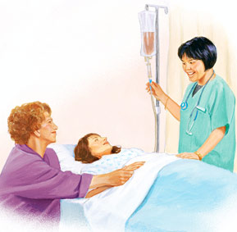

e) Give one function of each component of blood listed in the table below

|  |  |
| --- | --- |
| Component | Function |
| Thrombocytes |  |
| Leucocytes |  |
| Plasma |  |

(3 marks)

f) Kelly is blood type A Rh+. List the blood groups which would be suitable donors for

her transfusion.

________________________________________________________________________

________________________________________________________________________

(2 marks)

g) Describe what may happen in her body if Kelly is given a transfusion of an

incompatible blood group.

________________________________________________________________________

________________________________________________________________________

________________________________________________________________________

(2 marks)

h) Kelly’s mother is blood type O and her father is AB. Use a punnett square to demonstrate how it is possible for Kelly to be blood group A.

(5 marks)

**Section Three: Extended answer 20% (40 Marks)**

This section contains **three (3)** questions. You must answer **two (2)** questions. **You must answer question 39** and can choose **EITHER** Question 40 **or** Question 41. Write your answers in the space provided.

Spare pages are included at the end of this booklet. They can be used for planning your responses and/or as additional space if required to continue an answer.

Planning: If you use the spare pages for planning, indicate this clearly at the top of the page.

Continuing an answer: If you need to use more space to continue an answer, indicate in the original answer space where the answer is continued, i.e. give the page number. Write the number of the question(s) that you are continuing to answer at the top of the additional space page.

Responses could include clearly labelled diagrams with explanatory notes; lists of points with linking sentences; clearly labelled tables and graphs; and annotated flow diagrams with introductory notes.

Suggested working time for this section is 50 minutes.

**Answer question 39.**

**Question 39 (20 marks)**

1. Name the processes by which gametes are formed in the male and female reproductive system and state where each process occurs. While both processes involve meiosis, compare and contrast the processes and products formed in each case. (10 marks)
2. Describe the processes involved in two different reproductive technologies used to treat infertility. Include a risk, benefit and an ethical consideration for each of the processes described.

(10 marks)

Question number: __________________

________________________________________________________________________________

________________________________________________________________________________

________________________________________________________________________________

________________________________________________________________________________

________________________________________________________________________________

________________________________________________________________________________

________________________________________________________________________________

________________________________________________________________________________

________________________________________________________________________________

________________________________________________________________________________

________________________________________________________________________________

________________________________________________________________________________

________________________________________________________________________________

________________________________________________________________________________

________________________________________________________________________________

________________________________________________________________________________

________________________________________________________________________________

________________________________________________________________________________

________________________________________________________________________________

________________________________________________________________________________

________________________________________________________________________________

________________________________________________________________________________

________________________________________________________________________________

________________________________________________________________________________

________________________________________________________________________________

________________________________________________________________________________

________________________________________________________________________________

________________________________________________________________________________

________________________________________________________________________________

________________________________________________________________________________

________________________________________________________________________________

________________________________________________________________________________

________________________________________________________________________________

________________________________________________________________________________

Question number: __________________

________________________________________________________________________________

________________________________________________________________________________

________________________________________________________________________________

________________________________________________________________________________

________________________________________________________________________________

________________________________________________________________________________

________________________________________________________________________________

________________________________________________________________________________

________________________________________________________________________________

________________________________________________________________________________

________________________________________________________________________________

________________________________________________________________________________

________________________________________________________________________________

________________________________________________________________________________

________________________________________________________________________________

________________________________________________________________________________

________________________________________________________________________________

________________________________________________________________________________

________________________________________________________________________________

________________________________________________________________________________

________________________________________________________________________________

________________________________________________________________________________

________________________________________________________________________________

________________________________________________________________________________

________________________________________________________________________________

________________________________________________________________________________

________________________________________________________________________________

________________________________________________________________________________

________________________________________________________________________________

________________________________________________________________________________

________________________________________________________________________________

________________________________________________________________________________

________________________________________________________________________________

________________________________________________________________________________

Question number: __________________

________________________________________________________________________________

________________________________________________________________________________

________________________________________________________________________________

________________________________________________________________________________

________________________________________________________________________________

________________________________________________________________________________

________________________________________________________________________________

________________________________________________________________________________

________________________________________________________________________________

________________________________________________________________________________

________________________________________________________________________________

________________________________________________________________________________

________________________________________________________________________________

________________________________________________________________________________

________________________________________________________________________________

________________________________________________________________________________

________________________________________________________________________________

________________________________________________________________________________

________________________________________________________________________________

________________________________________________________________________________

________________________________________________________________________________

________________________________________________________________________________

________________________________________________________________________________

________________________________________________________________________________

________________________________________________________________________________

________________________________________________________________________________

________________________________________________________________________________

________________________________________________________________________________

________________________________________________________________________________

________________________________________________________________________________

________________________________________________________________________________

________________________________________________________________________________

________________________________________________________________________________

________________________________________________________________________________

**Answer either question 40 or 41.**

**Question 40 (20 marks)**

1. Describe the pathway an oxygen molecule takes from inside the alveoli to reach the tissue of an active muscle. In your answer include a description of the method of transport and the structures the oxygen passes through along its route. (8 marks)
2. The combined oral contraceptive pill is a highly effective form of birth control. Describe the role of hormones in regulating the female reproductive cycles and explain how hormones in contraceptives prevent pregnancy.

(12 marks)

**OR**

**Question 41 (20 marks)**  
  
Carbohydrates are an important nutrient found in many foods and essential for the healthy functioning of the body.

1. Describe how carbohydrates are digested and ways in which the products are efficiently absorbed by the body.

(12 marks)

1. Cellular respiration is vital to the functioning of the human body. Contrast aerobic and anaerobic respiration with reference to the reactants, products, location and amount of energy produced.

(8 marks)

Question number: __________________

________________________________________________________________________________

________________________________________________________________________________

________________________________________________________________________________

________________________________________________________________________________

________________________________________________________________________________

________________________________________________________________________________

________________________________________________________________________________

________________________________________________________________________________

________________________________________________________________________________

________________________________________________________________________________

________________________________________________________________________________

________________________________________________________________________________

________________________________________________________________________________

________________________________________________________________________________

________________________________________________________________________________

________________________________________________________________________________

________________________________________________________________________________

________________________________________________________________________________

________________________________________________________________________________

________________________________________________________________________________

________________________________________________________________________________

________________________________________________________________________________

________________________________________________________________________________

________________________________________________________________________________

________________________________________________________________________________

________________________________________________________________________________

________________________________________________________________________________

________________________________________________________________________________

________________________________________________________________________________

________________________________________________________________________________

________________________________________________________________________________

________________________________________________________________________________

________________________________________________________________________________

________________________________________________________________________________

Question number: __________________

________________________________________________________________________________

________________________________________________________________________________

________________________________________________________________________________

________________________________________________________________________________

________________________________________________________________________________

________________________________________________________________________________

________________________________________________________________________________

________________________________________________________________________________

________________________________________________________________________________

________________________________________________________________________________

________________________________________________________________________________

________________________________________________________________________________

________________________________________________________________________________

________________________________________________________________________________

________________________________________________________________________________

________________________________________________________________________________

________________________________________________________________________________

________________________________________________________________________________

________________________________________________________________________________

________________________________________________________________________________

________________________________________________________________________________

________________________________________________________________________________

________________________________________________________________________________

________________________________________________________________________________

________________________________________________________________________________

________________________________________________________________________________

________________________________________________________________________________

________________________________________________________________________________

________________________________________________________________________________

________________________________________________________________________________

________________________________________________________________________________

________________________________________________________________________________

________________________________________________________________________________

________________________________________________________________________________

Question number: __________________

________________________________________________________________________________

________________________________________________________________________________

________________________________________________________________________________

________________________________________________________________________________

________________________________________________________________________________

________________________________________________________________________________

________________________________________________________________________________

________________________________________________________________________________

________________________________________________________________________________

________________________________________________________________________________

________________________________________________________________________________

________________________________________________________________________________

________________________________________________________________________________

________________________________________________________________________________

________________________________________________________________________________

________________________________________________________________________________

________________________________________________________________________________

________________________________________________________________________________

________________________________________________________________________________

________________________________________________________________________________

________________________________________________________________________________

________________________________________________________________________________

________________________________________________________________________________

________________________________________________________________________________

________________________________________________________________________________

________________________________________________________________________________

________________________________________________________________________________

________________________________________________________________________________

________________________________________________________________________________

________________________________________________________________________________

________________________________________________________________________________

________________________________________________________________________________

________________________________________________________________________________

________________________________________________________________________________

Question number: __________________

________________________________________________________________________________

________________________________________________________________________________

________________________________________________________________________________

________________________________________________________________________________

________________________________________________________________________________

________________________________________________________________________________

________________________________________________________________________________

________________________________________________________________________________

________________________________________________________________________________

________________________________________________________________________________

________________________________________________________________________________

________________________________________________________________________________

________________________________________________________________________________

________________________________________________________________________________

________________________________________________________________________________

________________________________________________________________________________

________________________________________________________________________________

________________________________________________________________________________

________________________________________________________________________________

________________________________________________________________________________

________________________________________________________________________________

________________________________________________________________________________

________________________________________________________________________________

________________________________________________________________________________

________________________________________________________________________________

________________________________________________________________________________

________________________________________________________________________________

________________________________________________________________________________

________________________________________________________________________________

________________________________________________________________________________

________________________________________________________________________________

________________________________________________________________________________

________________________________________________________________________________

________________________________________________________________________________

Question number: __________________

________________________________________________________________________________

________________________________________________________________________________

________________________________________________________________________________

________________________________________________________________________________

________________________________________________________________________________

________________________________________________________________________________

________________________________________________________________________________

________________________________________________________________________________

________________________________________________________________________________

________________________________________________________________________________

________________________________________________________________________________

________________________________________________________________________________

________________________________________________________________________________

________________________________________________________________________________

________________________________________________________________________________

________________________________________________________________________________

________________________________________________________________________________

________________________________________________________________________________

________________________________________________________________________________

________________________________________________________________________________

________________________________________________________________________________

________________________________________________________________________________

________________________________________________________________________________

________________________________________________________________________________

________________________________________________________________________________

________________________________________________________________________________

________________________________________________________________________________

Spare grid for question 31 (a)

|  |  |  |  |  |  |  |  |  |  |  |  |  |  |  |  |  |  |
| --- | --- | --- | --- | --- | --- | --- | --- | --- | --- | --- | --- | --- | --- | --- | --- | --- | --- |
|  |  |  |  |  |  |  |  |  |  |  |  |  |  |  |  |  |  |
|  |  |  |  |  |  |  |  |  |  |  |  |  |  |  |  |  |  |
|  |  |  |  |  |  |  |  |  |  |  |  |  |  |  |  |  |  |
|  |  |  |  |  |  |  |  |  |  |  |  |  |  |  |  |  |  |
|  |  |  |  |  |  |  |  |  |  |  |  |  |  |  |  |  |  |
|  |  |  |  |  |  |  |  |  |  |  |  |  |  |  |  |  |  |
|  |  |  |  |  |  |  |  |  |  |  |  |  |  |  |  |  |  |
|  |  |  |  |  |  |  |  |  |  |  |  |  |  |  |  |  |  |
|  |  |  |  |  |  |  |  |  |  |  |  |  |  |  |  |  |  |
|  |  |  |  |  |  |  |  |  |  |  |  |  |  |  |  |  |  |
|  |  |  |  |  |  |  |  |  |  |  |  |  |  |  |  |  |  |
|  |  |  |  |  |  |  |  |  |  |  |  |  |  |  |  |  |  |
|  |  |  |  |  |  |  |  |  |  |  |  |  |  |  |  |  |  |
|  |  |  |  |  |  |  |  |  |  |  |  |  |  |  |  |  |  |
|  |  |  |  |  |  |  |  |  |  |  |  |  |  |  |  |  |  |
|  |  |  |  |  |  |  |  |  |  |  |  |  |  |  |  |  |  |
|  |  |  |  |  |  |  |  |  |  |  |  |  |  |  |  |  |  |
|  |  |  |  |  |  |  |  |  |  |  |  |  |  |  |  |  |  |
|  |  |  |  |  |  |  |  |  |  |  |  |  |  |  |  |  |  |
|  |  |  |  |  |  |  |  |  |  |  |  |  |  |  |  |  |  |
|  |  |  |  |  |  |  |  |  |  |  |  |  |  |  |  |  |  |
|  |  |  |  |  |  |  |  |  |  |  |  |  |  |  |  |  |  |
|  |  |  |  |  |  |  |  |  |  |  |  |  |  |  |  |  |  |
|  |  |  |  |  |  |  |  |  |  |  |  |  |  |  |  |  |  |
|  |  |  |  |  |  |  |  |  |  |  |  |  |  |  |  |  |  |
|  |  |  |  |  |  |  |  |  |  |  |  |  |  |  |  |  |  |
|  |  |  |  |  |  |  |  |  |  |  |  |  |  |  |  |  |  |
|  |  |  |  |  |  |  |  |  |  |  |  |  |  |  |  |  |  |
|  |  |  |  |  |  |  |  |  |  |  |  |  |  |  |  |  |  |
|  |  |  |  |  |  |  |  |  |  |  |  |  |  |  |  |  |  |
|  |  |  |  |  |  |  |  |  |  |  |  |  |  |  |  |  |  |
|  |  |  |  |  |  |  |  |  |  |  |  |  |  |  |  |  |  |
|  |  |  |  |  |  |  |  |  |  |  |  |  |  |  |  |  |  |
|  |  |  |  |  |  |  |  |  |  |  |  |  |  |  |  |  |  |
|  |  |  |  |  |  |  |  |  |  |  |  |  |  |  |  |  |  |
|  |  |  |  |  |  |  |  |  |  |  |  |  |  |  |  |  |  |